Parent Course Plan Review Instructions
- Go to http://gcis.gcic.edu/
- Login
- Click “View Portfolio Content”
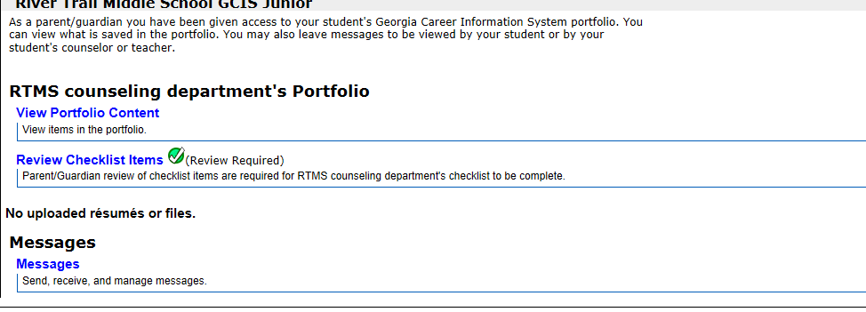
- Select “Course Planner”
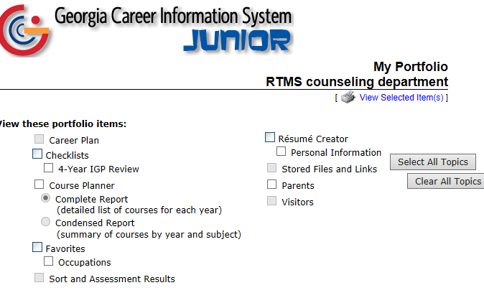
- Click “View Selected Item(s) at the bottom of the screen
- After reviewing their plan, close the window

- Click “Review Checklist Items”
- Click the box under “Parent Review” at the bottom of the page
The check just lets us know that you have viewed the plan. If you would like to make any changes, your students can login and change whatever you need.
